High conductive and transparent poly (3,4-thylenedioxythiophene): poly(styrenesulfonate) films by adding the sulfuric acid in solar cell
Xxx-Hxx xSxx, YuX-HXao Chen , WeXn-RaXy Chen and WaXlter WXater
Department of Electronic Engineering, National Formosa University, Hu-Wei, Yunlin, Taiwan
KXan-LXin ChXen
Department of Electronic Engineering, Fortune Institute of Technology, Kaohsiung, Taiwan
DeXi-WXei CXhou
Department of aviation & Communication Electronics, Air Force Institute of Technology, Kaohsiung, Taiwan
ChXien-Xung XXX*
Department of Applied Physics, National University of Kaohsiung, Kaohsiung, Taiwan
Corresponding author. Tel.: +88XX6 7 591XX9475; Fax: +886 7 5919XX357
E-mail: chiXXXen@nuk.edu.tw

ABSTRACT: The electrical properties of the poly(3,4-thylenedioxythiophene): poly(styrenesulfonate) (PEDOT: PSS) are strongly dependent on their chemical and physical structures. The mechanism of enhancement conductivity in the PEDOT: PSS films by adding various molar concentrations of H₂SO₄ were further studied. The sheet resistance of the doped PEDOT: PSS film enhanced with increasing the ratio of H₂SO₄, but it drops after the maximum sheet resistance. The reason for this phenomenon is that the H₂SO₄ was reacted with sorbitol preferentially. The non-conductive anions of some PSS⁻ were substituted by the conductive anions of HSO₄⁻ when the residual H₂SO₄ reacted with PSS. After the H₂SO₄ doped, the sheet resistance of H₂SO₄-doped PEDOT: PSS film is improved nearly 36%; the surface roughness is reduced from 1.268 nm to 0.822 nm and the transmittance is up to 91.6% in the visible wavelength range from 400 to 700 nm. However, the H₂SO₄-doped PEDOT: PSS films can be used as the transparent conductive electrode of optoelectronic devices in the future.

INTRODUCTION
The poly (3,4- thylenedioxythiophene): poly(styrenesulfonate) (PEDOT: PSS) is a conductive polymer blend, which has been widely used in the integration of electronic devices such as organic solar cells, actuators, capacitors, organic light-emitting devices and sensors. (Y. Wang et al. 2009) One of the fundamental requirements for operation of all organic optoelectronic devices is a stable anode interface. Indium tin oxide (ITO) has been widely used for organic optoelectronic devices due to its high optical transparency and high conductivity. However, the work function of ITO is low. The most common way is coated a buffer layer on the top of ITO surface. The buffer layer can export the carriers more efficiently.
Among these buffer layers, the PEDOT: PSS is superior to other materials. It is well known that the conductivity of the PEDOT: PSS film can be increased by the addition of polyols, such as sorbitol, DMSO or glycerol. (S.K.M. Jo¨nsson et al. 2003,Hu Yan et al. 2009,J.Y. Kim et al. 2002,Sungeun Park et al. 2011) In this work, the mechanism of enhancement conductivity for the PEDOT: PSS films by adding different molar dilute concentrations of H₂SO₄ were further studied. These

experimental results provided further evidences for our proposed mechanism.

Experimental
The SIGMA D-Sorbitol (98%) doped the Clevios PH 500 PEDOT: PSS was used as solution for preparation of thin films by a spin-coating method. The Sorbitol was added to the PEDOT: PSS directly, and then the doped PEDOT: PSS was stirred for 30 min at room temperature. The mixed solution was doped again by adding different molar concentrations of H₂SO₄. At last, the mixed PEDOT: PSS solution is the so-called the double doped PEDOT: PSS solution. The double doped PEDOT: PSS solution was coated by spinner on 2 × 2 cm² glass substrates and formed the double doped PEDOT: PSS film. The glass substrates were pre-cleaned with acetone, methanol and de-ionized (DI) water in an ultrasonic bath, sequentially. The spin-coating was performed at a rotation rate of 3500 rpm for 20 sec. The double doped PEDOT: PSS film was heated at 150 ℃ for 20 min on a hotplate in ambient lab conditions.
The sheet resistance was measured with four point sheet resistivity meter (SRM103). The transmittance and surface roughness of the thin films were characterized using the spectrophotometer (HITACHI U-3900) and atomic force microscope (AFM) (XE-70).

Results and Discussion
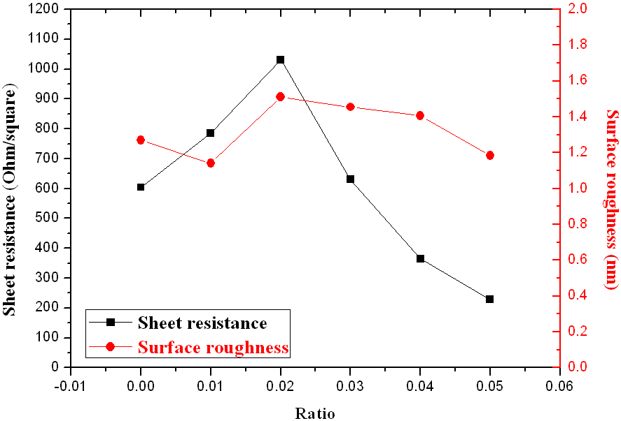
Figure 1 shows that the sheet resistance and surface roughness of the doped PEDOT: PSS film through adding 1.5M H₂SO₄ was measured by four-point probe and AFM, respectively. It is clear that the sheet resistance of the doped PEDOT: PSS film is affected by adding the various ratios of H₂SO₄. The sheet resistance of the doped PEDOT: PSS film enhanced with increasing the ratio of H₂SO₄, but it drops after the maximum sheet resistance. The sheet resistance value is reduced from 604 to 228 Ω/□. The surface roughness of the double doped PEDOT: PSS film is not almost changed.
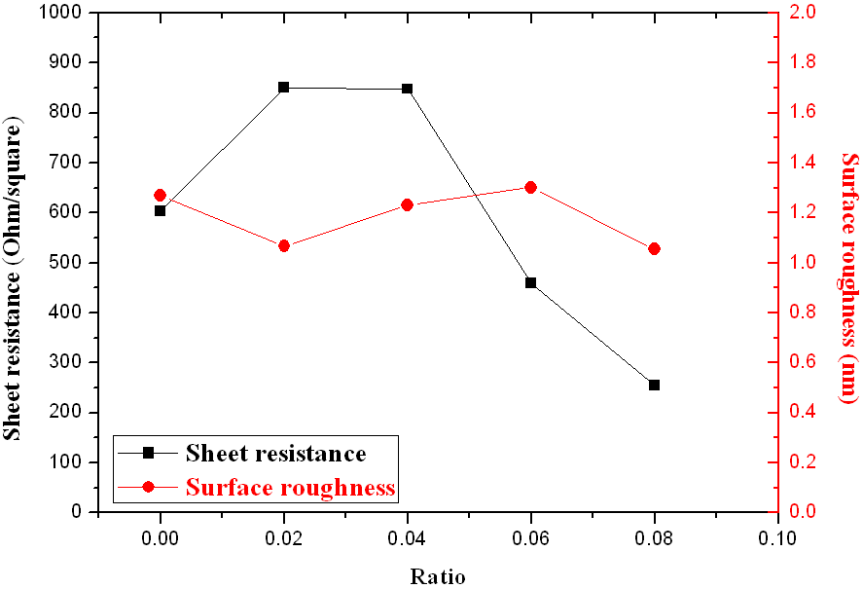
Figure 2 shows the sheet resistance and surface roughness of the doped PEDOT: PSS film through adding 1M H₂SO₄. The sheet resistance value is reduced from 604 to 255 Ω/□. The surface roughness of the 1M H₂SO₄ doped PEDOT: PSS film was smoother as compared with the 1.5M H₂SO₄ doped PEDOT: PSS film. Although the sheet resistance and surface roughness were improved slightly, we can’t clearly find the tendency from the 1M and 1.5M H₂SO₄ doped PEDOT: PSS films. This is due to the fact that the reaction rate of high concentration of H₂SO₄ is too fast. Thus, we reduce the molar concentration of H₂SO₄ again.
The reaction rate of H₂SO₄ was slowed down when the molar concentration of H₂SO₄ was 0.5M. The results are shown in Figure 3. The sheet resistance and surface roughness were reduced significantly. The sheet resistance is reduced from 604 to 216 Ω/□ and the surface roughness is also reduced from 1.268 to 0.822 nm.
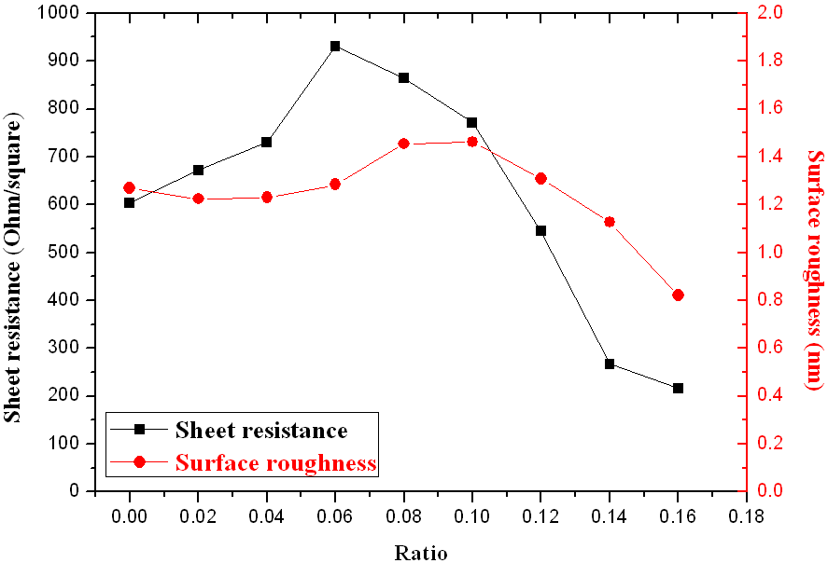
From Figure 1, Figure 2 and Figure 3, it can be seen that there is a common phenomenon. The sheet resistance was slightly increased with adding a small amount of H₂SO₄. The reason for this phenomenon is that the sulfuric acid was reacted with sorbitol preferentially. Thus, the aggregate effect combined PEDOT grains with sorbitol (S. Timpanaro et al. 2004) was destroyed. After the reaction, the residual H₂SO₄ reacted with PSS. The chemical reaction can be written as H₂SO₄ + PSS⁻ → HSO₄⁻+ PSSH. The non-conductive anions of some PSS⁻ were substituted by the conductive anions of HSO₄⁻. However, the substitution reactions will be favorable for the conductivity enhancement. (Yijie Xia et al. 2012)
Figure 4 shows the doped PEDOT: PSS films with different molar H₂SO₄ concentrations as a function of weight ratio of H₂SO₄ to PEDOT: PSS. The transparency of the doped PEDOT: PSS film can be affected by the H₂SO₄ treatment. The transmittance of the doped PEDOT: PSS film was decreased with increasing the ratio of H₂SO₄ to PEDOT: PSS. The lowest sheet resistance of 216 Ω/□ is obtained at 0.5M H₂SO₄-doped PEDOT: PSS film and at the weight ratio of 0.16 which transmittance in the visible wavelength range from 400 to 700 nm is 91.9%. The high transparency and low sheet resistance indicated that the 0.5M H₂SO₄-doped PEDOT: PSS films can be used as the transparent conductive electrode of optoelectronic devices.
Figure 1. The sheet resistance and surface roughness of doped PEDOT: PSS with different weight ratios of 1.5M H₂SO₄ to PEDOT: PSS.

Figure 2. The sheet resistance and surface roughness of doped PEDOT: PSS with different weight ratios of 1M H₂SO₄ to PEDOT: PSS.

Figure 3. The sheet resistance and surface roughness of doped PEDOT: PSS with different weight ratios of 0.5M H₂SO₄ to PEDOT: PSS.
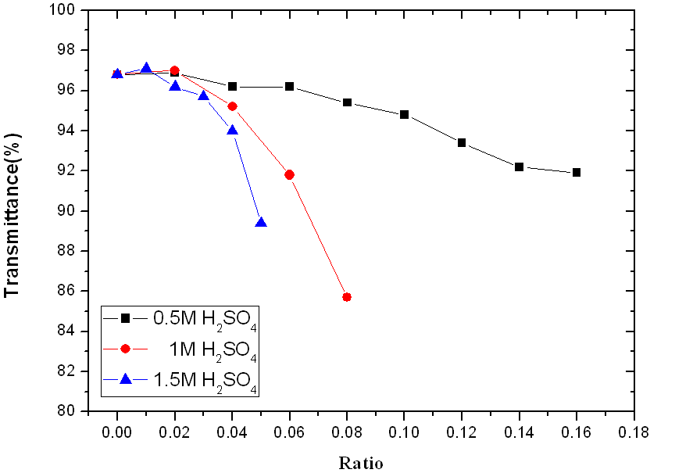
Figure 4. The transmittance of the doped PEDOT:PSS with different molar concentrations of H₂SO₄ as a function of weight ratio of H₂SO₄ to PEDOT: PSS.

Conclusion
In this paper, it has employed the non-contact AFM, four point sheet resistivity meter and U-3900 spectroscopy to investigate the origin of the sheet resistance decrease of H₂SO₄-doped PEDOT: PSS films. The doped PEDOT: PSS solution by adding the different molar concentrations of H₂SO₄ strongly affects the surface roughness, sheet resistance and transmittance. After the H₂SO₄ doped, the surface roughness is reduced from 1.268 nm to 0.822 nm. It's indicated that the surface of H₂SO₄-doped PEDOT: PSS film was smoother compared with the doped PEDOT: PSS film. The sheet resistance is improved from 604 to 216 Ω/□ by adding the dilute sulfuric acid. The decrease of the sheet resistance is due to the fact that the non-conductive anions of some PSS⁻ were substituted by the conductive anions of HSO₄⁻, namely that the substitution reactions will be favorable for the conductivity enhancement. The transmittance of the doped PEDOT: PSS film is decreased with increasing the weight ratio of H₂SO₄ to PEDOT: PSS. The transmittance of the 0.5M H₂SO₄-doped PEDOT: PSS film is above 91% in the visible wavelength range from 400 to 700 nm. However, the high transparency and low sheet resistance reveal that the H₂SO₄-doped PEDOT: PSS films can be used as the transparent conductive electrode of optoelectronic devices.

REFERENCES
Y. Wang, J. Phys, 2009.Conf. Ser. 152 012023.
S.K.M. Jo¨nsson, J. Birgerson, X. Crispin, G. Greczynski, W. Osikowicz, A.W. Denier van der Gon, W.R. Salaneck, M. Fahlman, 2003.Synyh. Met. 139 1-10.
Hu Yan, Hidenori Okuzaki, 2009.Synyh.Met.159 2225-2228.
J.Y. Kim, J.H. Jung, D.E. Lee, J. Joo, 2002. Synyh. Met.126 311-316.
Sungeun Park, Sung Ju Tark, Donghwan Kim, Curr. , 2011.Appl. Phys. 11 1299-1301.
S. Timpanaro, M. Kemerink, F.J. Touwslager, M.M. De Kok, S. Schrader, Chem, 2004. Phys. Lett. 394 339-343.
Yijie Xia, Kuan Sun, and Jianyong Ouyang,2012. Adv. Mater. 24 2436-2440.

